**Software requirement Specification (SRS)**

**Project Title: Ngo Management System**

**Requirements:**

We need to build a software for Ngo Management System. The application will have following feature:

1. There will be different type users like Admin, senior officer, officer, field assistant etc.
2. There will be account type like daily, monthly saving account and loan account.
3. There will be nominee and one account may have one or more nominees and one nominee may have one or more account.
4. Account opening balance at least 100 tk.
5. An account holder must have a deposit book.
6. An account holder must take a loan above 1000000 tk.
7. An account holder must see their total amount, total deposit, total loan.
8. An account holder must check their how much money pay of their total amount of loan.
9. An account holder checks their profit and losses.
10. An account holder sees their daily, monthly and Yearly Deposit.

**Analysis and Design Part:**

1. **Brainstorming Diagram:**

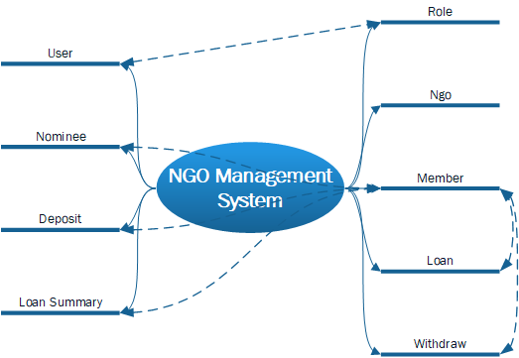

1. **Use Case Diagram:**

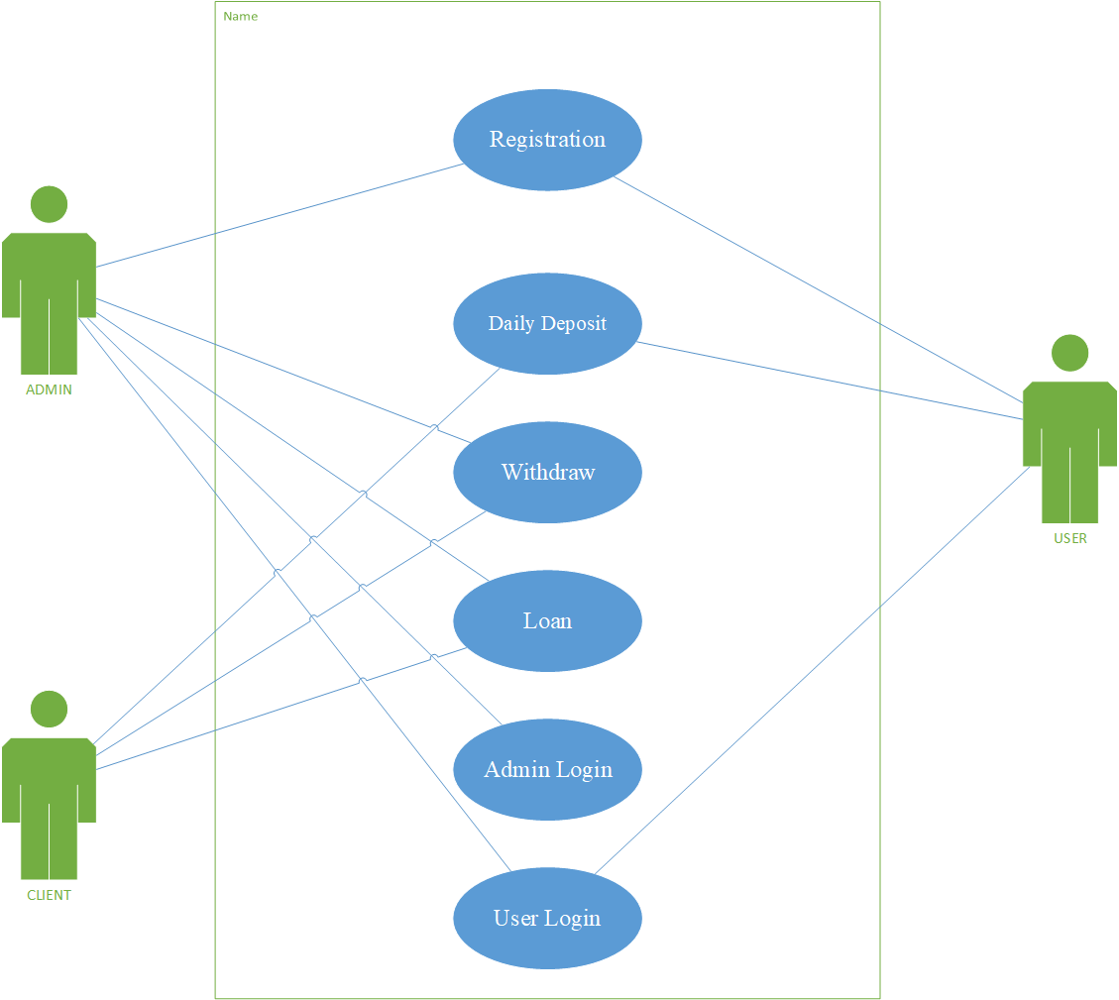

1. **Class Diagram:**

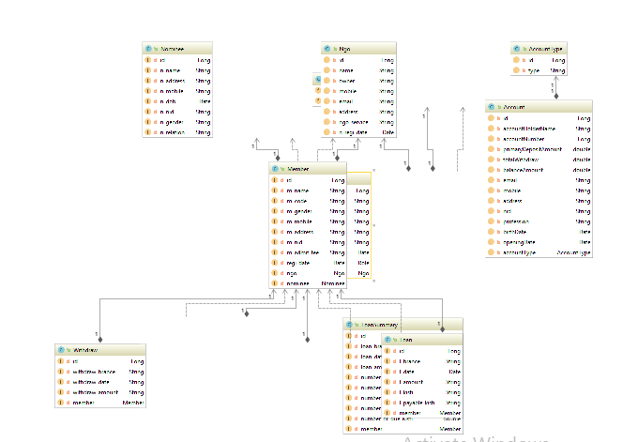

1. **Entity Relationship Diagram:**

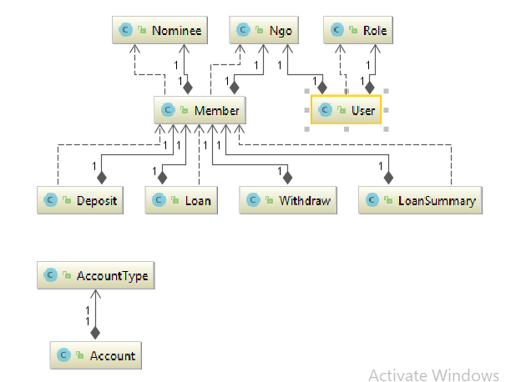

1. **Front End Diagram:**